Vanier College

Program Comprehensive Assessment Project

May 26th, 2023

**Modelling Charge and Current of RLC Circuits**

**with Differential Equations**

Kevin Sementilli

Presented to:

Christian Stahn

Ivan T. Ivanov

201-HTK-05 Linear Algebra II

201-HTL-VA Differential Equations

Table of Content

1. **Abstract**  **4**
2. **Introduction 4**
3. **Differential Equations Derivation 5**

3.1 Kirchhoff’s Loop Rule . . . . . . . . . . . . . . . . . . . . . . . . . . . . . . . . . . . . . . . . . . . . . . 6

3.2 Junction Rule . . . . . . . . . . . . . . . . . . . . . . . . . . . . . . . . . . . . . . . . . . . . . . . . . . . . . 7

1. **Reduction of Order 8**

4.1 First order rewrite . . . . . . . . . . . . . . . . . . . . . . . . . . . . . . . . . . . . . . . . . . . . . . . . . 8

4.2 Matrix Representation . . . . . . . . . . . . . . . . . . . . . . . . . . . . . . . . . . . . . . . . . . . . . . 9

1. **Setting Parameters 9**

7.1 Resistors . . . . . . . . . . . . . . . . . . . . . . . . . . . . . . . . . . . . . . . . . . . . . . . . . . . . . . . . 9

7.2 Capacitors . . . . . . . . . . . . . . . . . . . . . . . . . . . . . . . . . . . . . . . . . . . . . . . . . . . . . . . 9

7.3 Inductors . . . . . . . . . . . . . . . . . . . . . . . . . . . . . . . . . . . . . . . . . . . . . . . . . . . . . . . 10

7.4 Driving force . . . . . . . . . . . . . . . . . . . . . . . . . . . . . . . . . . . . . . . . . . . . . . . . . . . . 10

1. **Solving Numerically 10**

6.1 Displaying the solution to the system . . . . . . . . . . . . . . . . . . . . . . . . . . . . . . . . . 10

6.2 Satisfying Algebraic Relations . . . . . . . . . . . . . . . . . . . . . . . . . . . . . . . . . . . . . . 11

6.2.a Satisfying the equation . . . . . . . . . . . . . . . . . . . . . . . . . . . . . . . . . . . . . 11

6.2.b Satisfying the equation . . . . . . . . . . . . . . . . . . . . . . . . . . . . . . . . . . . . . 11

6.2.c Satisfying the equation . . . . . . . . . . . . . . . . . . . . . . . . . . . . . . . . . . . . . 12

1. **The Circuit Under No Damping Effect 12**

7.1 Diagonalization . . . . . . . . . . . . . . . . . . . . . . . . . . . . . . . . . . . . . . . . . . . . . . . . . . 13

7.2 Eigenvectors and Eigenvalues . . . . . . . . . . . . . . . . . . . . . . . . . . . . . . . . . . . . . . . 15

7.3 Jordan Normal Form . . . . . . . . . . . . . . . . . . . . . . . . . . . . . . . . . . . . . . . . . . . . . . 17

7.4 General Solution . . . . . . . . . . . . . . . . . . . . . . . . . . . . . . . . . . . . . . . . . . . . . . . . . 20

7.5 Initial Conditions . . . . . . . . . . . . . . . . . . . . . . . . . . . . . . . . . . . . . . . . . . . . . . . . . 22

1. **Normal Modes 24**

8.1 Normal Mode 1 . . . . . . . . . . . . . . . . . . . . . . . . . . . . . . . . . . . . . . . . . . . . . . . . . . 25

8.2 Normal Mode 2 . . . . . . . . . . . . . . . . . . . . . . . . . . . . . . . . . . . . . . . . . . . . . . . . . . 26

8.3 Normal Mode 3 . . . . . . . . . . . . . . . . . . . . . . . . . . . . . . . . . . . . . . . . . . . . . . . . . . 27

8.4 Normal Mode 4 . . . . . . . . . . . . . . . . . . . . . . . . . . . . . . . . . . . . . . . . . . . . . . . . . . 27

8.5 Normal Mode 5 . . . . . . . . . . . . . . . . . . . . . . . . . . . . . . . . . . . . . . . . . . . . . . . . . . 28

8.6 Normal Mode 6 . . . . . . . . . . . . . . . . . . . . . . . . . . . . . . . . . . . . . . . . . . . . . . . . . . 28

1. **Conclusion 29**
2. **Appendix 31**

**11) References 32**

Abstract

This goal of this paper is to implement systems of differential equations and linear algebra to model the charges and currents of a three-loop electrical circuit. The circuit in question can be modelled with twelve first order differential equations. Nine of them come from a reduction of order with the three second order differential equations derived by Kirchhoff’s voltage rule. The other three are algebraic constraints between the currents derived from the junction rule. By forming a matrix and solving for the system’s general solution numerically and analytically, the fundamental modes or normal modes of oscillation are uncovered to analyze the circuit’s behaviour when the circuit has no resistance. The normal modes yields a purely harmonic relationship between the six capacitors and three inductors because the induced current from the inductors flows through the capacitors, which enables them to discharge at the same rate. Furthermore, the results of the analytical solution to the circuit under no resistance will oscillate infinitely. This comes from the purely complex eigenvalues of the matrix formed by the system of differential equations.

Introduction

Differential equations (DE) are one of the most useful tools to determine the rate of change of a particular system. This paper will demonstrate how differential equations and linear algebraic techniques can predict the change in charges (Q) and the change in current (I) of an AC circuit at any given time. The goal in modelling the changes in charge and current of the circuit is to uncover the fundamental modes of oscillations and discover the frequency of the driving force that will yield the largest oscillations. Since there are three resistors, it can be hypothesized that the amplitude of oscillation will never go to infinity and therefore will have a finite maximum amplitude. The circuit in question consists of inductors (L), capacitors (C), reductors (R), and an alternating energy source (). The following diagram displays the electrical circuit that will be modelled in this paper.

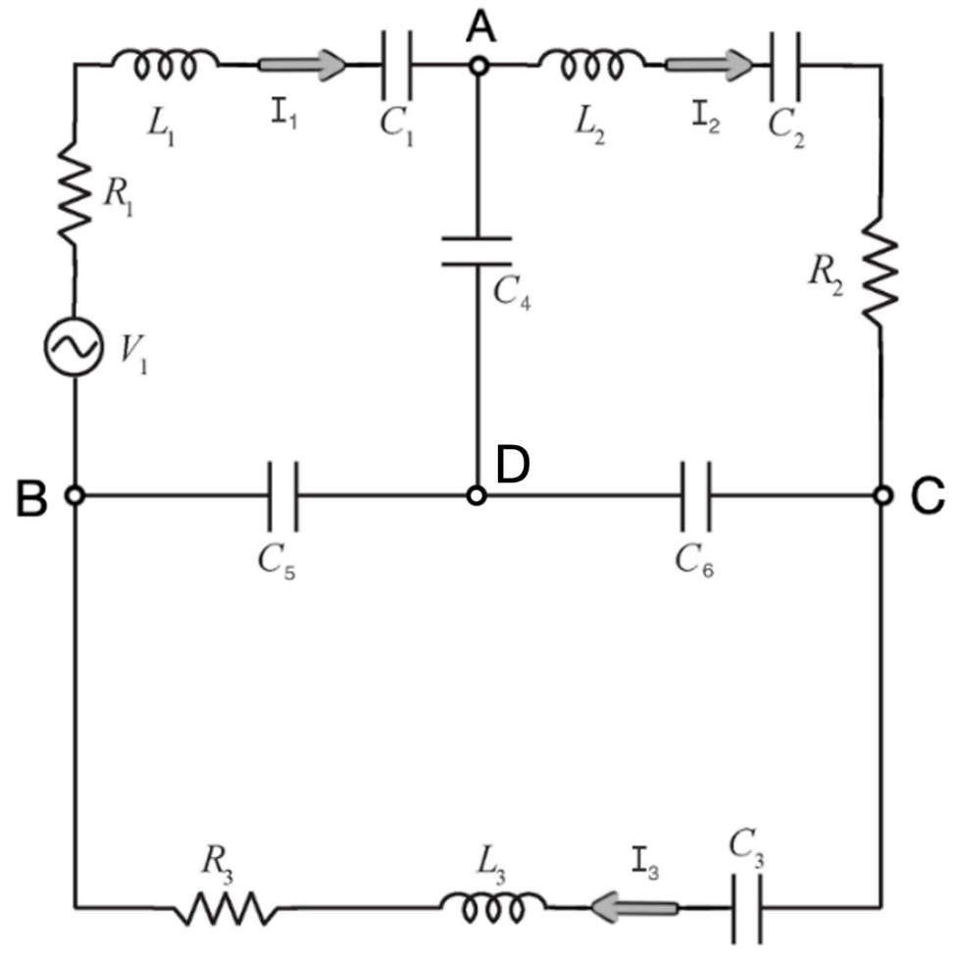

Figure 1: The circuit consists of three resistors, three inductors, 6 capacitors (one in each branch), and an oscillating current generator in loop 1.

Differential Equation Derivation

Deriving the differential equations of the circuit will make use of Kirchhoff’s voltage and current Laws. Firstly, Kirchhoff’s voltage law states that the sum of voltage drops around a closed loop is equal to zero (). Each component to the circuit will induce a voltage drop when following the current of the loop. The voltage drop caused by a resistor can be determined using the formula,

(1) , where R is the resistance (Ω)

Similarly, the voltage drop of capacitors and inductors can be found using the formulas,

(2) , where C is the capacitance (F) and Q is the charge (C),

(3) and , where L is the inductance (H).

For the purpose of solving the DE’s, equations (1) and (3) can be rewritten as,

(4)

(5) .

This comes from the fact that current is the change in charges over time. This is evident by the analysis of the unit of current, , where c is in coulombs, a measure of charge, and s is seconds. Therefore, current is a change in charge of time. In other words, current can rewritten as the derivative of charge (). This would also imply that the change in current can be written as the second derivative of the charge (). Therefore, any given loop that consists of inductors, resistors, and capacitors can be written as a 2nd order DE. In this case, three loops will yield three 2nd order DE’s, creating a system of DE’s.

1. Kirchhoff’s loop rule

Loop 1:

Loop 2:

Loop 3:

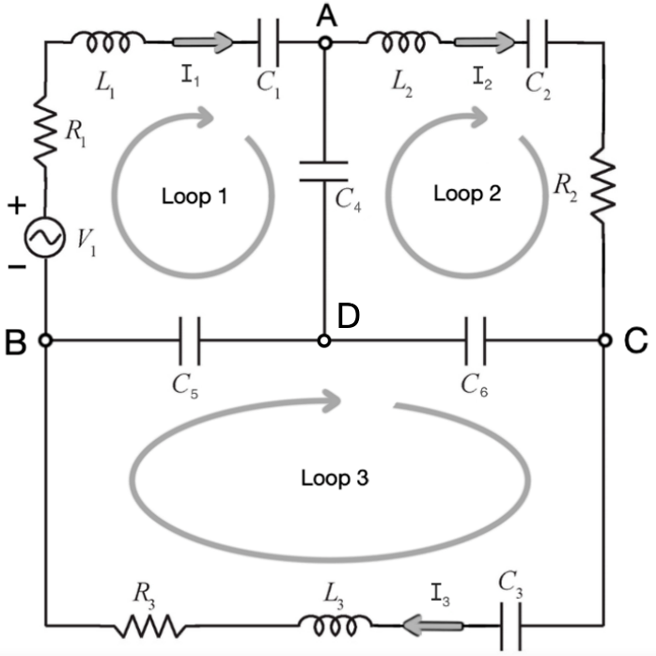

In simpler examples, the three second order DE’s will be enough to solve the system. However, from figure 1, there are three capacitors in the middle of the circuit. This means that the charges flowing into C4, C5, and C6 will be supplied by two loops, simultaneously. This causes a dependence on the other charges from the main three branches, resulting in a system of multivariate DE’s. The use of the junction rule at nodes A, B, and C, will extract three 1st order DE’s which we can use to solve the system. Node D is not needed because it is simply a recombination of the other three and will not provide additional information on the circuit’s currents. Therefore, these three equations are the algebraic relations between 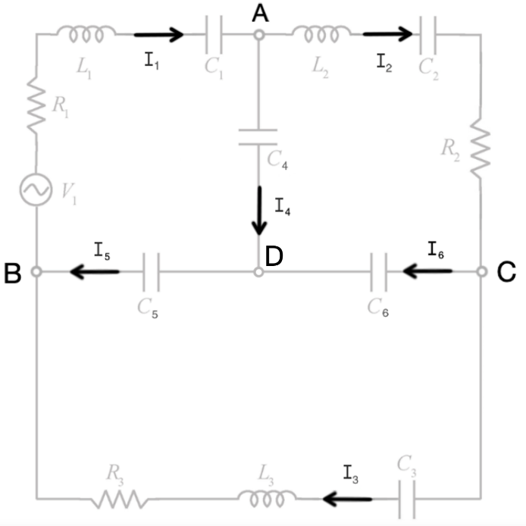the currents in each branch.

1. Junction rule

Junction A:

Junction B:

Junction C:

* The junction rule equations, substituted into equations IV, V, VI, establishing a dependence on the changes in Q4, Q5, Q6.
* The next step is to differentiate both sizes in order to get equations for the double derivative of Q4, Q5, Q6.

Reduction of Order

Now the question is, how does one solve a system of DE’s? The most efficient way to solve a system of 2nd order DE’s is to perform a reduction of order. Applying this technique will convert the system into 1st degree DE’s and therefore reduce the order of the system. In this particular case, the method of reduction of order will provide six additional 1st order DE’s, having a total of nine differential equations. Including the three equations obtained from the junction rule, there are now twelve equations (six DEs of charges and six DEs of currents).

1. First order Rewrite

* Since the equations of , , are already known, they can be substituted into the previous three equations to get a relationship between the other currents.
* With these twelve equations, a matrix can be formed to represent the system of DE’s.

1. Matrix Representation

The twelve DE’s can be expressed as a matrix A,

(6) ,

describing the non-homogenous system, with **V** being the driving force (battery).

Setting Parameters

With the matrix A above, it is possible to compute eigenvalues and eigenvectors to observe the behavior of the system under various initial conditions and parameters. To do so, there is a very simple code in a python library called NumPy that calculates these e-values/e-vectors. However, Python will need actual numbers to be able to compute e-vectors and e-values. Therefore, the next step is to assign values to the electrical circuit’s components (inductors, capacitors, and resistors) and obtain a numerical matrix A to perform the calculations mentioned earlier. Note that the magnitude of the driving force will also be parameterized, however, the frequency of oscillations will be left blank in order to consider the circuit under different parameterizations.

1. Resistors

1. Capacitors
2. Inductors
3. Driving Force

Solving Numerically

1. Displaying the solution to the system

The easiest way to solve the system is to use a numerical method called sol_ivp from the library SciPy. Integrate in python. The code uses RK-45 which is a part of the Runge-Kutta family of numerical integration method of solving first order ordinary differential equation. This method uses weighted averages of four increments to approximate the value of the solution. Therefore, this method of solving would be the quickest and most efficient way of solving the system. The only downfall is that the numerical solver will not display or calculate a general formula of the solutions and interpretations will be purely geometrical. This can be done by plotting the solution using a python code called plt.plot from the matplotlib.pyplot library.

The following graph is a visual representation of the solution to the changes in charges of the first capacitor C1 that uses the numerical method to plot the solution.

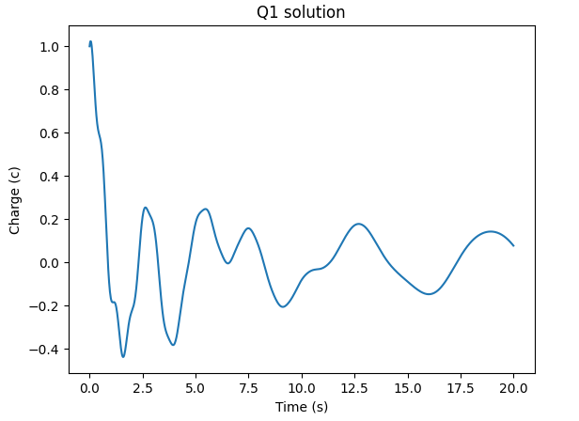

From the graph above, we can analyze the solution to the changes in the charges of the first capacitor C1. From the initial condition, the capacitor has 1 C at t = 0, then decreases and oscillates erratically until t ≈ 15, where the internal frequency begins to dissipate, and the driving force takes hold of the solution where the charges stabilize from 0.2 C to - 0.2 C.

1. Satisfying Algebraic relationships

The numerical integration technique can be used to justify the algebraic constraints placed upon the system by implementing the equations derived by the junction rule. Then differentiating them to get intuition about the derivatives of . These equations (, , ) act as algebraic relationships between the solutions to the change in currents and therefore are a great way to verify if the solution is accurate. In other words, displaying the solution to should yield the same graph as the solution to , the same concept applies to and . Therefore, by deploying the numerical solver and plotting the two solutions on a single graph, we can verify if the solution satisfies the junction rule equations.

1. Satisfying the equation

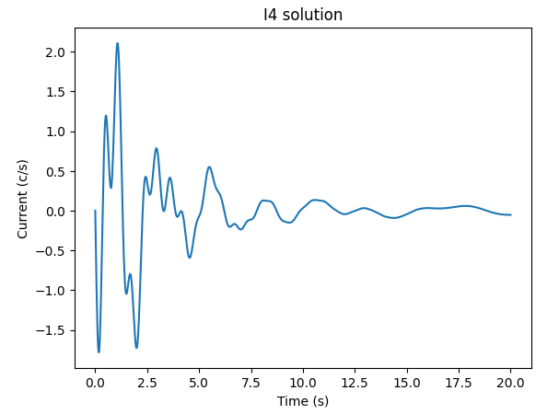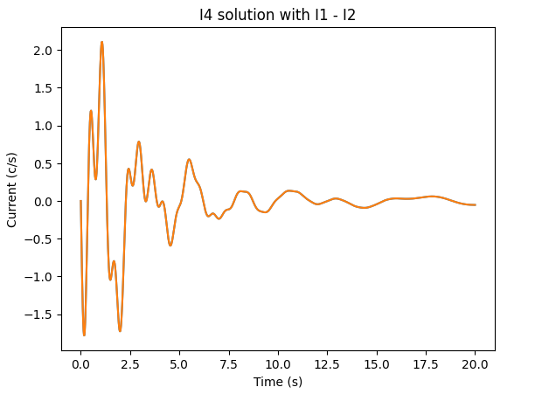

1. Satisfying the equation

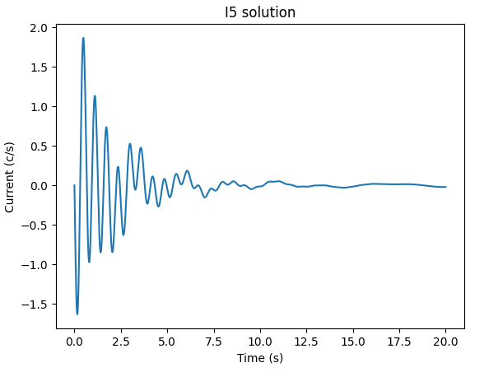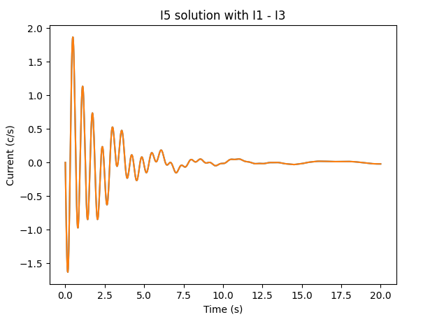

1. Satisfying the equation

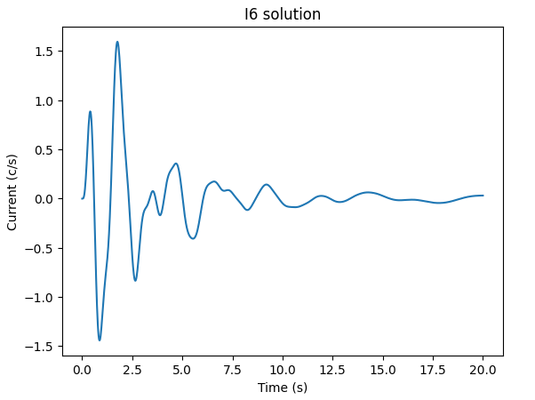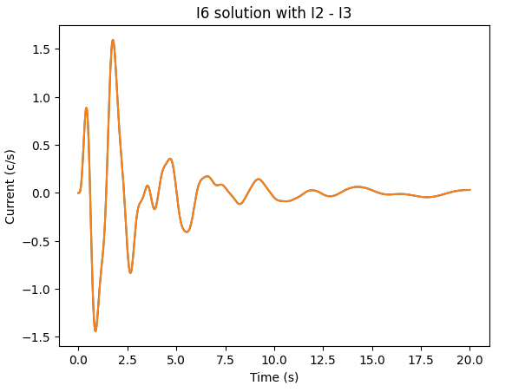

The graphs on the left plot the solution to I4, I5, and I6, while the graphs on the right plot the solutions to I4, I5, and I6, with their associated equations from the junction rule. In all three cases, there is a perfect overlap between the solutions to I4, I5, I6, and the solutions to , , . This means that the solutions to the system of DE’s abides by the junction rule and the algebraic relationship created from the junction rule hold true. However, this also implies that the initial conditions must also abide by this constraint. For example, if and , then I4 must be the difference of the two. Giving an initial condition that does not follow this rule will result in discrepancies in the solutions.

The Circuit Under No Damping Effect

Now that the system’s solutions are verified to be accurate, it is possible to analyze the system under different initial conditions and parameterizations. The first case that can be considered is the system under no damping effect, that is, with no resistance and no driving force. With that being said, it can be hypothesized that the solution to the system of DE’s will be pure oscillations. This hypothesis is quite logical since with no decaying factor, the solution should oscillate infinitely.

To analyze the circuit in this state, we set all resistors to zero, which in the physical aspect of the circuit, would result in a circuit containing only inductors and capacitors. Therefore, the matrix A, derived from the first order differential equations, will end up looking like the illustration below.

With the previous parameterization, but setting the resistors to 0, the matrix representing the system becomes,

1. Diagonalization

Deploying a numerical solver will not give any intuition of what the system is doing, so get a deeper understanding of what the circuit will do under these conditions, an ansatz can be used to derive the solution to the system. This ansatz states that the general solution to a system of first order differential equations can be written as

Ansatz: ,

where ’s are all eigenvalues of the matrix A and ’s are all eigenvectors associated to the eigenvalues.

The procedure of obtaining eigenvalues is quite simple for small matrices and can be found with only two operations.

Once the eigenvalues are found, it is a simple matter of plugging the values of into the matrix and solving for the kernel of this matrix.

Eigenvalues and eigenvectors come from the concept of linear transformations in which any vector multiplied by a given matrix gets mapped to a scalar multiple of that same vector. In order words, an eigenvector is a vector that gets mapped to the same vector when multiplied by the matrix A. The scalar multiple that the vector gets mapped to is called an eigenvalue.

This concept of finding eigenvalues/eigenvectors can be applied to a process called diagonalization in which any invertible nxn matrix with its algebraic multiplicity equal to its geometric multiplicity, meaning that every eigenvalue has an associated eigenvector, can be diagonalized.

Diagonalization is process of converting the matrix as a product of matrices , where P is the column matrix of all eigenvectors,

* And D is a diagonal matrix composed of eigenvalues along the diagonal,

Combining this with the previous ansatz, this becomes a matrix exponential that forms the fundamental matrix of solutions which contains all solutions to the system of DE’s,

,

The ansatz states that the solution is an exponential function with eigenvalues as the coefficients of t. However, we must first prove this is true before we can deploy it as a reliable method of solving DE’s. To do so, we must consider the power series of the exponential function.

Applying the power series to a matrix, we obtain

However, if the matrix A is replaced by its diagonalization, we see that the exponent gets distributed to the diagonal matrix D, in which all values of that matrix are simply raised to power of the exponent.

Now, from the fact that the middle term can be written as , since all the P’s and ’s will cancel out except for the first P and the last .

Therefore, the power series becomes,

This provides the proof for writing the general solution to a system of DE’s as exponential functions with eigenvalues in the exponent. Therefore, this method can be deployed to the system.

1. Eigenvectors and Eigenvalues

Despite all this, doing this for such a large system like the 12x12 system we have representing the circuit will be quite strenuous. Instead, there is a library in python called NumPy with the function np.linalg_eig() that calculates eigenvalues in mere milliseconds. Then, deploying a code np.printoption to display the result such that they are visually symmetric and can be analyzed more easily. These two codes provide a very quick and efficient way of calculating eigenvalues and eigenvectors.

That being said, the eigenvalues and eigenvectors of the matrix A are:

, , ,

, , ,

, , ,

, ,

These are the eigenvalues and eigenvectors of the matrix A that NumPy has calculated. The first six eigenvalues are purely imaginary numbers. Consequently, the eigenvalues are the complex conjugates of . This is because the matrix A is real, meaning it does not contain any numbers in the complex domain, and therefore, the complex values must cancel out. The only way for that to happen is if the complex number’s conjugate is present.

1. Jordan Normal Form

is also an eigenvalue of A and it has an algebraic multiplicity of 6. However, there are only three vectors associated to these eigenvalues. Despite the program calculating twelve eigenvectors, are repeats of **.** This is likely because the program calculates each separately and can only find three vectors from this eigenvector. Then it calculates these eigenvectors for the other three which ends up being the same as the of three. Consequently, there are three eigenvectors missing, which indicates that the algebraic multiplicity of eigenvalues does not equal the geometric multiplicity of eigenvectors. This means that the matrix A cannot be diagonalized because it does not have enough eigenvectors for the number of eigenvalues. Instead, the matrix can be expressed in the Jordan normal form. This form has a similar procedure of writing A as the product of three nxn matrices containing the column spaces of its eigenvectors, but with an extra step of creating a Jordan normal chain. With this form, the matrix containing eigenvalues, which was originally the matrix D in the process of diagonalization, is now the matrix J. Like diagonalization, the matrix J has the entirety of its entries in the main diagonal, but a value of 1 is placed above the entry containing the eigenvalues that is missing an eigenvector. This is commonly expressed as

The difference between this and diagonalization is that J is a non-diagonal matrix of the form:

From this J, we can see that the matrix is not diagonal and therefore will not behave the same way under matrix exponentiation. In fact, from the ansatz of the Jordan normal form

The ansatz above can be proved again using the power series of the exponential function.

Therefore, the Jordan normal form will yield a linear factor in the general solution to the system. With that being said, the next step before solving for the general solution to the system is to find the vectors that make up the Jordan normal chain. Since the rank of A is 9, it is very easy to see that there will be three vectors in the basis for the null space of A. This can be deduced from the fact that, due to the algebraic constraint caused by the junction rule, the last three rows are linear combinations of the first three current equations. The equation to solve for Jordan normal vectors can be written as:

or

However, since the eigenvalue is 0, the equation to find Jordan normal vectors becomes:

From this equation, finding the Jordan normal vectors just becomes a question of finding the Kernel of A. Finding the null space of a 12x12 matrix can be quite strenuous, however, looking at the block structure of A,

The row reduction can be done to the 6x6 matrix B. Doing so will allow us to find three vectors () in the null space of B, which can be easily translated to A. Once again, using the block structure of A, the vectors from the Kernel of B, which have 6 entries which can be written as vectors for A, such that,

, are 12 entry vectors.

Then using the definition of the Jordan chain corresponding to when the eigenvalue is equal to zero. This definition states,

This means there will be six vectors that make up the Jordan normal chain, each corresponding to , who’s multiplicity is six. Therefore, the Jordan normal form compensates for the lack of eigenvectors by taking some from the null space of A.

* With these three generalized vectors of B, the Jordan normal chain of A can be formed.

With all the vectors of the matrix A, matrix P and P -1, containing all the eigenvectors and Jordan normal vectors can be form. Doing this will allow us to verify that the system is indeed a Jordan normal form if and only if it satisfies the equation, . This matrix multiplication can be done through NumPy in which the “@” symbol represents matrix multiplication and the function P.inv() can be used to find the inverse of P.

The electrical circuit’s matrix J has been proven to look like:

With this information, the general real solution can be constructed.

1. General Solution

In the general solution to the system, the terms with will be reduced to a linear function from the properties of the Jordan chain and the fact that anything raises to the power of 0 is 1, . Therefore, the first six terms are more relevant in determining the behaviour of the circuit. With this information, we can deploy a linear algebraic technique that separates the real and imaginary parts of the eigenvectors and considers them as two separate terms of the solution to construct the real solution to the system. Doing so will simplify calculations since only 3 eigenvalues/eigenvectors are needed to obtain the six terms that determine the behaviour of the solution. At this point the general solution to the system can be written as:

where is the coefficient of the complex eigenvalues.

To simplify this equation, we can deploy Euler’s formula to eliminate the imaginary part of the complex exponential functions in the first six terms of the general solution.

Since there is no real part of the complex number, the solution will be composed of cosines and sines, resulting in pure oscillations. To simplify calculations, the first six terms are calculated simultaneously.

The next and final step to obtaining the analytical solution is distributing the sines and cosines into the vectors. This way, imaginary numbers cancel out and results in the general real solution.

1. Initial Conditions

Through observations of the general solution and the matrix P, the coefficients of the particular solution can be found through the reduced echelon form of P, augmented with the initial condition imposed on the system. In consequence, verifying an arbitrary initial condition that satisfy the junction rule could be very insightful on how the system behaves when given an initial condition that reflects physical phenomena. Doing this in python can be very easily done with two simple commands in the SymPy library. Since the matrix P is already defined, it can be converted to SymPy by redefining the variable as sp.Matrix(P). Then a simple code that allows the user to add columns to P with .row_join(). The next step is to let the program perform the row-reduction on this augmented matrix with .rref().

Consider the initial condition in which the electrical circuit, at t = 0, has no charge in all capacitors and a current of 1 A in . From the junction rule, become zero.

Now consider an arbitrary initial condition that does not abide by the current constraints.

Performing the RREF on python yields:

This result shows that any initial condition that abides by the junction rule makes all the Jordan normal vectors go to zero and therefore, the system oscillates endlessly, since there is no resistance. On the other hand, initial conditions that do not abide by this rule have non-zero coefficients in the linear growing factors. This can be seen in the example above in which and . In fact, these coefficients are quite large, meaning that the system goes to infinity very quickly.

Normal Modes

A normal mode is a particular solution to the system in which the initial condition allows the system to have simple harmonic motion. These can be analyzed to get insight on the behavior of electrical circuits, particularly in the design and analysis of filters, oscillators, and other circuits that involve resonance. By analyzing the normal modes of a circuit, engineers can predict how the circuit will respond to different inputs and design the circuit to have specific frequency characteristics. In addition, normal mode analysis can be used to study the stability of a circuit and to identify potential sources of unwanted oscillations or resonances.

The normal modes of any system can be found by setting the initial condition to an eigenvector. In this case, since the solution is real and the real and imaginary parts were split up, we must consider the normal modes created from both the real and imaginary parts of the eigenvectors separately. By making the initial condition the real or imaginary part of an eigenvector, all coefficients of the general solutions become zero except for the one that the eigenvector is associated to. To uncover the normal modes of the circuit, time is usually set to zero, making the linear factors and sine function go to zero. If the current is considered the derivative of charge, there should be six normal modes (since there are six oscillating terms) that yield harmonic motion.

1. First Normal Mode

Therefore, the first normal mode considers the real part of **v**1 as an initial condition. So, at t = 0, the linearly growing factors cancel out, and the system is left with,

This equation can now be considered as a linear combination of the real part of **v**1 in which the only possible solution would be and all other coefficients equal to zero ().

Once again, solving this by hand wouldn’t be very efficient, therefore we can use programming to solve for the coefficients. There are two ways to solve for this. The first method, which was used in this paper previously to prove the algebraic constraints, solves numerically using sol_ivp and defining the derivatives of each variable. The second method is to use matrix exponentiation, a code, expm(t*A)), from the scipy.linalg package that takes exponents of the matrix A at finite amount of evaluation points and multiplies it to the initial condition. Then it takes each evaluation point as a column of a 12xn matrix (where n is the number of evaluation points. For a smooth graph, 1001 evaluation points were taken, making the matrix a 12x1001. Consequently, this method will be used to obtain the solution to the first normal mode of the system.

From the general solution above, the particular solution to the first normal mode of the system can be defined as:

From the graph, the charge in capacitor 1 oscillates with a frequency of 10.08 Hz as a sine function.

1. Second Normal Mode

The second normal mode can be obtained by setting the initial condition to the imaginary part of **v**1. Doing so will lead to all the coefficients to be zero except for .Therefore, the particular solution to the system’s charges and currents can be written as:

From the results above, the second normal mode yields the charge in the first capacitor as a negative cosine function and its associated current is a positive sine function.

1. Third Normal Mode

The third normal mode can be obtained by taking the real part of **v**3.

1. Fourth Normal Mode

The fourth normal mode can be obtained by taking the Imaginary part of **v**3.

1. Fifth Normal Mode

The fifth normal mode of the electrical circuit sets the initial condition to the real part of **v**5.

1. Sixth Normal Mode

The sixth and final normal mode of the system uses the imaginary part of **v**5 as the initial condition.

In all normal modes, the current oscillates in opposite function from the charges. In other words, if the charge oscillates as a sine function, then the current oscillates as a cosine function and vice versa. This comes from the fact that all the eigenvectors have complex numbers in the first six entries and real numbers in the last six entries. This results in the same relationship between all currents and charges of a specific mode.

Conclusion

In conclusion, the goal of this paper was to model the charges and currents of the three-loop electrical circuit with three resistors, three inductors, and six capacitors. Since there is a capacitor in each branch of the circuit, this caused a dependence on the current flowing through the capacitors of the three interior branches to the exterior capacitors. Therefore, algebraic constraints were put in place to relate the changes in current of the three center branches to the exterior branches of the circuit. This was done through Kirchhoff’s current rule in which relationships between currents at each node were established. Then, a reduction of order was performed on the three equations derived from Kirchhoff’s voltage rule, in which the three second order differential equations were transformed into nine first order DE’s. Because the second order DEs of the exterior branches were already known, they could be substituted into the junction rule equations after being differentiated. Doing this supplied three additional first order DEs which took into consideration the changes in current of the inner branches of the circuit.

The next step was to verify that these algebraic constraints held true for the system of twelve DEs. This was done via python’s sol_ivp numerical solver to plot the solution of the charges going into capacitor four, compared to charges from capacitor one subtracted by the charges of capacitor two. As expected, these turned out to be the same and therefore, proofed that the current constraints held true for the system.

The paper then took a turn into analyzing the circuit’s behaviour under no resistance. To do so, an analysis of the block structure of the matrix A, containing the twelve equations derived previously, was performed. This revealed a Jordan normal form caused by the six eigenvalues equal to zero. Therefore, a Jordan normal chain was formed with the six eigenvectors associated to the eigenvalue equal to zero. The other six eigenvalues were purely imaginary, meaning that the three of the imaginary eigenvalues are simply the conjugate of the other three. Consequently, the formulation of the general solution to the system under no damping effect resulted in six terms containing trigonometric functions, three linearly growing factors, and three constant terms.

Interestingly enough, the vectors obtained by the Jordan normal chain are rather simple and yield interesting implications for the initial conditions. That is, analyzing the matrix P, formed by all eigenvectors of A, the last six columns have the opposite relationship to the junction rule. Recall the equations derived from the junction rule: , , . Viewing the matrix P, there is a relationship in the Jordan normal chain vectors. Therefore, when the system is given an initial condition that satisfies the current constraints, then all linearly growing factors, will have zero components, meaning that only the first six terms and the constant terms will remain in the solution. In other words, this limits the initial conditions that the system can take to any condition that conforms to the currents’ algebraic constraints.

From a physical standpoint, this phenomenon is caused by the fact that the capacitors have a set limit of the number of charges it can hold and therefore will never increase as a linear function. Before that happens, the charges already built up inside the capacitor will reach its limiting capacity and begin to discharge. Therefore, the model must reflect this behaviour by limiting the initial conditions imposed on the system of differential equations. However, it is quite interesting how the mathematical model of the system encompasses an unphysical model in which the system grows linearly. Perhaps in another mechanical system, this linear growth could be a factor that plays into the equation of the solution and determines the behaviour of that system.

Nonetheless, these linear factors do not take part in normal modes. With no resistance, and all coefficients going to zero, the solution is left with only one frequency of oscillation. This yield periodic motion. For this particular circuit, there are six normal modes, that means that six different initial conditions result in periodic motion of all charges and currents flowing into each capacitor. Theses initial conditions can be found very easily by considering the real and imaginary part of the eigenvectors. On top of that, the internal frequency of the system becomes the eigenvalue that is associate to the eigenvector. Therefore, normal modes can be found simply from eigenvalue/eigenvector analysis.

Appendix

Satisfying initial conditions:

<https://colab.research.google.com/drive/18SFAkLxWtulXsngsKYbhu3ZNRsojM0Me?usp=sharing>

Finding Jordan normal vectors:

[Nulspace{{0,0,0,0,0,0,1,0,0,0,0,0},{0,0,0,0,0,0,0,1,0,0,0,0},{0,0,0,0,0,0,0,0,1,0,0,0},{0,0,0,0,0,0,0,0,0,1,0,0},{0,0,0,0,0,0,0,0,0,0,1,0},{0,0,0,0,0,0,0,0,0,0,0,1},{-25,0,0,-Divide[25,3],-50,0,0,0,0,0,0,0},{0,-Divide[25,6],0,Divide[25,9],0,-Divide[10,3],0,0,0,0,0,0},{0,0,-Divide[25,8],0,25,5,0,0,0,0,0,0},{-25,Divide[25,6],0,-Divide[100,9],-50,Divide[10,3],0,0,0,0,0,0},{-25,0,Divide[25,8],-Divide[25,3],-75,-5,0,0,0,0,0,0},{0,-Divide[25,6],Divide[25,8],Divide[25,9],-25,-Divide[25,3],0,0,0,0,0,0}} - Wolfram|Alpha (wolframalpha.com)](https://www.wolframalpha.com/input?i2d=true&i=Nul+space%7B%7B0%2C0%2C0%2C0%2C0%2C0%2C1%2C0%2C0%2C0%2C0%2C0%7D%2C%7B0%2C0%2C0%2C0%2C0%2C0%2C0%2C1%2C0%2C0%2C0%2C0%7D%2C%7B0%2C0%2C0%2C0%2C0%2C0%2C0%2C0%2C1%2C0%2C0%2C0%7D%2C%7B0%2C0%2C0%2C0%2C0%2C0%2C0%2C0%2C0%2C1%2C0%2C0%7D%2C%7B0%2C0%2C0%2C0%2C0%2C0%2C0%2C0%2C0%2C0%2C1%2C0%7D%2C%7B0%2C0%2C0%2C0%2C0%2C0%2C0%2C0%2C0%2C0%2C0%2C1%7D%2C%7B-25%2C0%2C0%2C-Divide%5B25%2C3%5D%2C-50%2C0%2C0%2C0%2C0%2C0%2C0%2C0%7D%2C%7B0%2C-Divide%5B25%2C6%5D%2C0%2CDivide%5B25%2C9%5D%2C0%2C-Divide%5B10%2C3%5D%2C0%2C0%2C0%2C0%2C0%2C0%7D%2C%7B0%2C0%2C-Divide%5B25%2C8%5D%2C0%2C25%2C5%2C0%2C0%2C0%2C0%2C0%2C0%7D%2C%7B-25%2CDivide%5B25%2C6%5D%2C0%2C-Divide%5B100%2C9%5D%2C-50%2CDivide%5B10%2C3%5D%2C0%2C0%2C0%2C0%2C0%2C0%7D%2C%7B-25%2C0%2CDivide%5B25%2C8%5D%2C-Divide%5B25%2C3%5D%2C-75%2C-5%2C0%2C0%2C0%2C0%2C0%2C0%7D%2C%7B0%2C-Divide%5B25%2C6%5D%2CDivide%5B25%2C8%5D%2CDivide%5B25%2C9%5D%2C-25%2C-Divide%5B25%2C3%5D%2C0%2C0%2C0%2C0%2C0%2C0%7D%7D)

[Step-by-Step Calculator (symbolab.com)](https://www.symbolab.com/solver/step-by-step/%5Cbegin%7Bpmatrix%7D-%5Cfrac%7B1%7D%7BL%5Ccdot%20C%7D%260%260%26-%5Cfrac%7B1%7D%7BL%5Ccdot%20V%7D%26-%5Cfrac%7B1%7D%7BL%5Ccdot%20W%7D%260%5C%5C%200%26-%5Cfrac%7B1%7D%7Bn%5Ccdot%20Q%7D%260%26%5Cfrac%7B1%7D%7Bn%5Ccdot%20V%7D%260%26-%5Cfrac%7B1%7D%7Bn%5Ccdot%20T%7D%5C%5C%200%260%26-%5Cfrac%7B1%7D%7Bm%5Ccdot%20U%7D%260%26%5Cfrac%7B1%7D%7Bm%5Ccdot%20W%7D%26%5Cfrac%7B1%7D%7Bm%5Ccdot%20T%7D%5C%5C%20-%5Cfrac%7B1%7D%7BL%5Ccdot%20C%7D%26%5Cfrac%7B1%7D%7Bn%5Ccdot%20Q%7D%260%26-%5Cfrac%7B1%7D%7BL%5Ccdot%20V%7D-%5Cfrac%7B1%7D%7Bn%5Ccdot%20V%7D%26-%5Cfrac%7B1%7D%7BL%5Ccdot%20W%7D%26%5Cfrac%7B1%7D%7Bn%5Ccdot%20T%7D%5C%5C%20-%5Cfrac%7B1%7D%7BL%5Ccdot%20C%7D%260%26%5Cfrac%7B1%7D%7Bm%5Ccdot%20U%7D%26-%5Cfrac%7B1%7D%7BL%5Ccdot%20V%7D%26-%5Cfrac%7B1%7D%7BL%5Ccdot%20W%7D-%5Cfrac%7B1%7D%7Bm%5Ccdot%20W%7D%26-%5Cfrac%7B1%7D%7Bm%5Ccdot%20T%7D%5C%5C%200%26-%5Cfrac%7B1%7D%7Bn%5Ccdot%20Q%7D%26%5Cfrac%7B1%7D%7Bm%5Ccdot%20U%7D%26%5Cfrac%7B1%7D%7Bn%5Ccdot%20V%7D%26-%5Cfrac%7B1%7D%7Bm%5Ccdot%20W%7D%26-%5Cfrac%7B1%7D%7Bn%5Ccdot%20T%7D-%5Cfrac%7B1%7D%7Bm%5Ccdot%20T%7D%5Cend%7Bpmatrix%7D?or=input) , Parameters: C = C1 , Q = C2, U = C3, V = C4, W = C5, T = C6

Inductors: L = L1 , n = L2 , m = L3

Eigenvectors, eigenvalues, Jordan normal, and initial conditions:

<https://colab.research.google.com/drive/1v6jsCRORuhUhH_6UibyuSxpONbLfPgC?usp=sharing>

Normal modes using sol_ivp:

<https://colab.research.google.com/drive/1C-RMkaIE7e1-W3Cjtr8Yp3yHEOAOzy4?usp=sharing>

Normal modes using matrix exponentiation:

<https://colab.research.google.com/drive/1PUZYzAGTjCSsEsPEfSWbUI0EA_J9hRmn?usp=sharing>

References

[1] *Kirchhoff’s laws (article), Circuits, Khan Academy*. (n.d.). Khan Academy. https://www.khanacademy.org/science/physics/circuits-topic/circuits-resistance/a/ee-kirchhoffs-laws

[2] *Differential Equations - Introduction*. (n.d.). https://www.mathsisfun.com/calculus/differential-equations.html